**Learners have to come up with a Report to support the answers to the following questions and suggestions**

Objective Questions

1. Are there any tables with duplicate or missing null values? If so, how would you handle them?

Answer- There are no Null or Duplicate rows in the data.

Example of query used for this task-

**Null-**

**SELECT * FROM tags**

**WHERE id IS NULL**

**OR tag_name IS NULL**

**OR created_at IS NULL;**

**Duplicate-**

**SELECT id, image_url, user_id, created_dat, COUNT(*)**

**FROM photos**

**GROUP BY id, image_url, user_id, created_dat**

**HAVING COUNT(*) > 1;**

-------------------------------------------------------

1. What is the distribution of user activity levels (e.g., number of posts, likes, comments) across the user base?

Answer

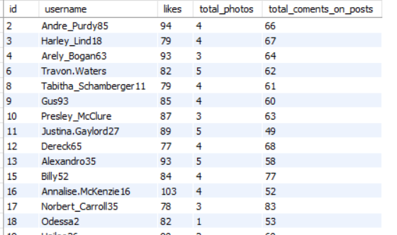

with comments_per_users as (

select user_id, count(id) as total_coments_on_posts

from comments

group by 1

),

likes_per_users as (

select user_id, count(photo_id) as likes

from likes

group by 1

),

posts_per_users as (

select user_id,count(id) as total_photos

from photos

group by 1

)

select id, username, likes,total_photos,total_coments_on_posts

from

users u join likes_per_users l

on u.id = l.user_id

join comments_per_users c on u.id = c.user_id

join posts_per_users p on u.id = p.user_id

order by id;

**Explanation**- This query outputs the total number of likes, photo posts, comments done by an user. In addition, the user activity level is the sum of likes, photo posts, comments done by the respective user.

1. Calculate the average number of tags per post (photo_tags and photos tables).

with cte as (Select photo_id, count(tag_id) as tags_count

from photo_tags

group by photo_id)

Select sum(tags_count)/count(photo_id) as avg_tags_per_post from cte;

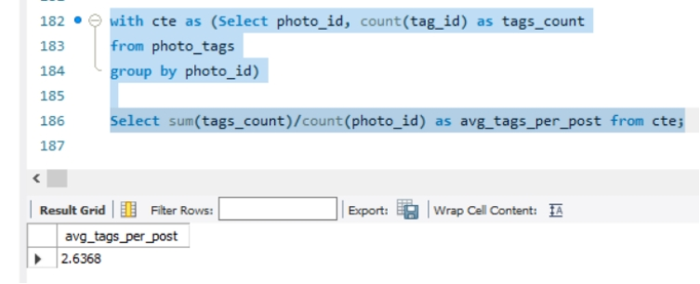

-----------------------------

1. Identify the top users with the highest engagement rates (likes, comments) on their posts and rank them.

Answer-

with comments_per_users as (

select user_id, count(id) as total_coments_on_posts

from comments

group by 1

),

likes_per_users as (

select user_id, count(photo_id) as likes

from likes

group by 1

),

user_engagement as (select id, username, sum(total_coments_on_posts + likes) as engagement_rate

from users u

join likes_per_users l

on u.id = l.user_id

join comments_per_users c on u.id = c.user_id

group by 1

)

select *, dense_rank() over(order by engagement_rate desc) as engagement_ranking

from

user_engagement

order by engagement_ranking;

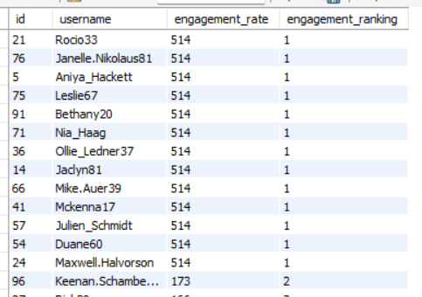

Explanation- The first CTE (comments_per_user) counts the total number of comments done by a user, the second CTE (likes_per_users) counts the number of likes done by an user. And the third CTE (user_engagement) which uses the above two CTEs counts the total number of comments and likes. Finally the last select statement ranks these users based on their sum of likes and counts.

1. Which users have the highest number of followers and followings?

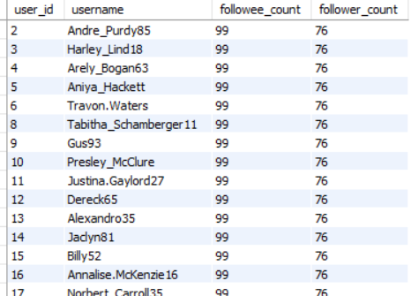

with followee_cte as (Select u.id, u.username, count(f.followee_id) followee_count

from users u join follows f

on u.id=f.follower_id

group by u.id),

follower_cte as (select u.id, u.username, count(f.follower_id) as follower_count

from users u join follows f

on u.id=f.followee_id

group by u.id)

select r.id as user_id, r.username, e.followee_count, r.follower_count

from followee_cte e join follower_cte r

on r.id=e.id

order by r.follower_count desc, e.followee_count asc;

**Explanation**- The first CTE (followee_cte) counts the number of followee for each user. The second CTE (follower_cte) counts the number of followers for each user. The third and final select statement, represents the number of followers, and followees for each user.

1. Calculate the average engagement rate (likes, comments) per post for each user.

with avg_comment as (select user_id, username, round(sum(comment_count)/count(photo_id),1) as average_comment_count

from (Select u.id as user_id, u.username, p.id as photo_id, count(c.id) as comment_count

from users u

left join photos p

on u.id=p.user_id

join comments c

on p.id=c.photo_id

group by u.id, p.id) alias1

group by user_id, username),

avg_like as (select user_id, round(sum(like_count)/count(photo_id),1) as average_like_count

from (Select u.id as user_id, p.id as photo_id, count(l.photo_id) as like_count

from users u

right join photos p

on u.id=p.user_id

join likes l

on p.id=l.photo_id

group by u.id, p.id) alias2

group by user_id)

select c.user_id, c.username, round(l.average_like_count+c.average_comment_count/2,1)

as average_engagement_rate

from avg_comment c join avg_like l

on c.user_id=l.user_id

group by c.user_id, c.username;

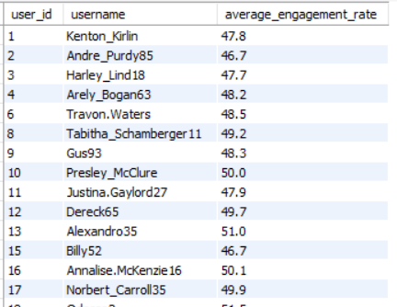

**Explaination**- In the subquery of the first CTE (‘avg_comment’) i determined the average number of comments per post for each user using group by and aggregate functions. In main query of the same CTE I determined the average count of comments for each post per user. Furthermore, I used the same approach in the second CTE (avg_like) for determining the average count of likes for each post per user.

Later, I combined both the CTEs in which I added the average count of comments and likes and devided by 2 to get the average engagement rate for each user.

1. Get the list of users who have never liked any post (users and likes tables)

Answer-

with user_likes as (

Select u.id, u.username, count(l.photo_id) as likes_count

from users u

left join likes l

on l.user_id=u.id

group by u.id

)

Select id, username from user_likes

where likes_count = 0;

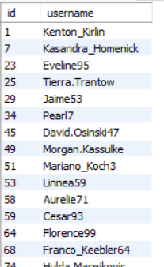

1. How can you leverage user-generated content (posts, hashtags, photo tags) to create more personalized and engaging ad campaigns?

Answer- The social media company can identify the users with high number of likes and comments and show ads on them.

with tagcount as (

Select l.user_id, p.photo_id, t.tag_name,

count(tag_name) over(partition by tag_name order by user_id) as count_tag

from likes l join photo_tags p

on l.photo_id=p.photo_id

left join tags t

on p.tag_id=t.id

order by user_id)

Select user_id, tag_name, count(count_tag) as frequency_of_tag_used

from tagcount

group by user_id, tag_name

order by user_id, count(count_tag) desc;

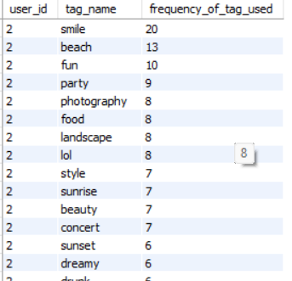

Explanation- In the CTE (tagcount) I determined the name and count of tags (using window function) per photo for each user. Later in the query I outputted the user id, tag name, and the count of a particular tag used by a specific user. The final output is sorted based on user id, and count of tags in descending order for each user.

The above table represents all the tags and its frequency of use by a user. The social media company can use this data to target their campaign based on the type of tags a particular user have used most of the times.

1. Are there any correlations between user activity levels and specific content types (e.g., photos, videos, reels)? How can this information guide content creation and curation strategies?

Answer-

with likes_per_users as (

select

user_id, count(photo_id) as num_likes

from

likes

group by 1

),

comments_per_posts as (

select

user_id, count(comment_text) as num_coments_on_posts

from

comments

group by 1

),

posts_per_users as (

select

user_id, count(image_url) as posts

from

photos

group by 1

),

engagement_per_user as (

select

username as users_name,

p.user_id,

p.id,

sum(num_likes + num_coments_on_posts + posts) as total_engagement_rate

from

photos p

join likes_per_users c1 on p.user_id = c1.user_id

join comments_per_posts c2 on p.user_id = c2.user_id

join users u on p.user_id = u.id

join posts_per_users c3 on p.user_id = c3.user_id

group by 1, 2, 3

),

engagement_percentage as (

select

users_name,

sum(round(100 * (num_likes / total_engagement_rate), 2)) as num_likes_percent,

sum(round(100 * (posts / total_engagement_rate), 2)) as posts_percent,

sum(round(100 * (num_coments_on_posts / total_engagement_rate), 2)) as comment_percent,

sum(round(100 * (total_engagement_rate / total_engagement_rate), 2)) as total_engagement_percent

from

engagement_per_user c4

join likes_per_users c1 on c4.user_id = c1.user_id

join comments_per_posts c2 on c4.user_id = c2.user_id

join users u on c4.user_id = u.id

join posts_per_users c3 on c4.user_id = c3.user_id

group by 1

)

select *, dense_rank() over (order by total_engagement_percent desc, posts_percent desc, num_likes_percent desc) as ranks

from

engagement_percentage

order by ranks;

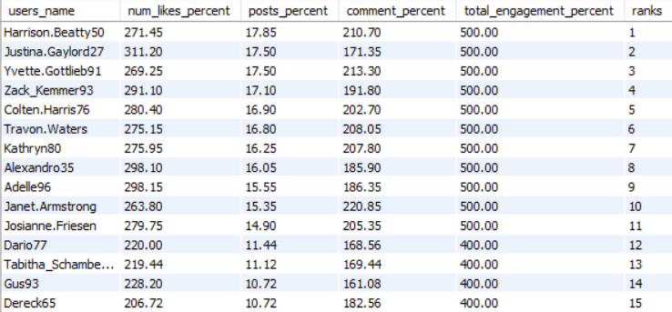

Explanation-

The analysis involved summing all three activity count columns in a fourth CTE to derive user activity levels. Next, the number of likes was divided by the total engagement rate to calculate the percentage of likes per user. A similar method was applied to determine both the post percentage and the comment percentage. The dense_rank function was then utilized to distinguish users with the highest engagement rates. The output indicated that users with higher engagement rates tended to post more photos compared to those with lower engagement rates. This suggests a strong correlation between user activity levels and specific content types.

1. Calculate the total number of likes, comments, and photo tags for each user.

with comments_per_users as (

select c.user_id, u.username, count(c.id) as total_coments

from comments c join users u

on c.user_id=u.id

group by c.user_id, u.username

),

likes_per_users as (

select l.user_id, u.username, count(photo_id) as likes

from likes l join users u

on l.user_id=u.id

group by user_id,u.username

),

tags_per_users as (

Select u.id as user_id, u.username, count(pt.tag_id) as tag_count

from users u

right join photos p

on u.id=p.user_id

join photo_tags pt

on p.id=pt.photo_id

group by u.id, u.username

)

select u.id, u.username, l.likes, c.total_coments, t.tag_count

from

users u join likes_per_users l

on u.id = l.user_id

join comments_per_users c on u.id = c.user_id

join tags_per_users t on u.id = t.user_id

order by c.total_coments desc, l.likes desc, t.tag_count desc;

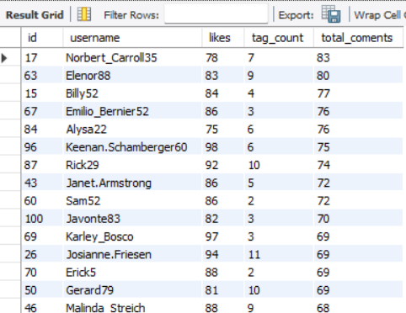

Explanation-

I created three CTEs to count the number of likes, comments, and photo tags. Then, I grouped the data by user_id to calculate the total count of likes, comments, and tags for each user.

1. Rank users based on their total engagement (likes, comments, shares) over a month.

Answer-

with likes_per_posts as (

select

id, count(photo_id) as num_likes

from

likes l

join

photos p on l.photo_id = p.id

group by 1

),

comments_per_post as (

select

photo_id, count(comment_text) as num_coments_on_posts

from

comments

group by 1

),

per_month_engagement_ranking as (

select

username as users_name,

month(created_at) as months,

sum(num_likes + num_coments_on_posts) as total_engagement_rate,

dense_rank() over(partition by month(created_at)

order by sum(num_likes + num_coments_on_posts) desc) month_wise_engagement_rank

from

photos p

join

likes_per_posts c1 on p.id = c1.id

join

comments_per_post c2 on p.id = c2.photo_id

join

users u on p.user_id = u.id

group by 1, month(created_at)

)

select

*

from

per_month_engagement_ranking

order by 2;

Explaination- In this query, I calculated and ranked user engagement on posts by month. First, I counted the number of likes per post by joining the likes and photos tables. Then, I counted the number of comments on each post. After that, I combined the likes and comments data to calculate the total engagement for each post. I grouped the results by username and month, then assigned a rank to each user based on their total engagement for that month. Finally, I selected and displayed the monthly engagement rankings, ordered by month*.*

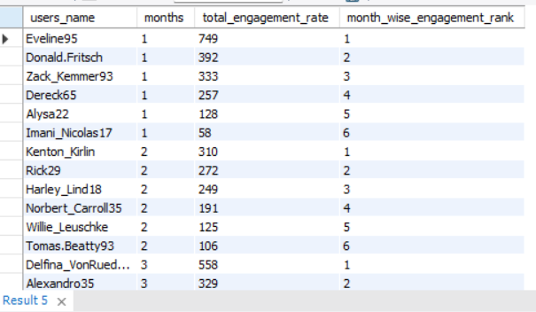

1. Retrieve the hashtags that have been used in posts with the highest average number of likes. Use a CTE to calculate the average likes for each hashtag first.

Answer-

with likes_per_photo as (

select

photo_id, count(user_id) as num_likes

from

likes

group by 1

),

avg_likes_per_tag_rank as (

select

tag_name, round(avg(num_likes), 2) as avg_num_likes,

dense_rank() over(order by avg(num_likes) desc) as tag_avg_likes_rank

from

likes_per_photo c1

join

photo_tags p on c1.photo_id = p.photo_id

join

tags t on t.id = p.tag_id

group by 1

)

select

upper(tag_name) as max_liked_tag,

avg_num_likes as max_avg_num_likes,

tag_avg_likes_rank

from

avg_likes_per_tag_rank

where

tag_avg_likes_rank = 1

order by 2;



Explaination- In this query, I retrieved the hashtags used in posts with the highest average number of likes. First, I used a CTE (Common Table Expression) to calculate the number of likes for each photo by grouping the likes data. Then, I calculated the average number of likes for each hashtag by joining the likes data with the photo tags and tags tables. I ranked the hashtags based on their average likes using the dense_rank() function. Finally, I selected and displayed the hashtag with the highest average number of likes, converting the tag name to uppercase and ordering the results by the average number of likes.

1. Retrieve the users who have started following someone after being followed by that person

with Users_followed_after_being_followed as (

SELECT DISTINCT fe.follower_id AS user_who_followed_after, fe.followee_id AS followed_by

FROM

follows fe

JOIN

follows fo ON fe.followee_id = fo.follower_id

AND fe.follower_id != fo.follower_id

WHERE

fe.follower_id = fo.followee_id

)

SELECT DISTINCT username AS Later_followed_users

FROM

Users_followed_after_being_followed c1

JOIN users u ON c1.user_who_followed_after = u.id

ORDER BY 1;

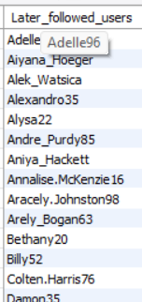

In this query, I retrieved users who started following someone after being followed by that person. I used a CTE called Users_followed_after_being_followed to identify cases where a user followed someone after being followed by them. This was achieved by joining the follows table on the follower and followee relationship, ensuring that the follower IDs were different but matched in reverse order. Finally, I selected and displayed the usernames of users who followed back, ensuring no duplicates, and ordered the results alphabetically.

Subjective Questions

1. Based on user engagement and activity levels, which users would you consider the most loyal or valuable? How would you reward or incentivize these users?

Answer-

with comments_per_users as (

select user_id, count(id) as total_coments_per_user

from comments

group by 1

),

likes_per_users as (

select user_id, count(photo_id) as likes

from likes

group by 1

),

posts_per_user as (

Select user_id, count(image_url) as total_posts

From photos

Group by 1

),

user_engagement as (select id, username, sum(total_coments_per_user + likes) as engagement_rate,

sum(total_posts + total_coments_per_user + likes) as activity_level_users

from users u

join likes_per_users l

on u.id = l.user_id

join comments_per_users c on u.id = c.user_id

join posts_per_user p on u.id=p.user_id

group by 1

)

select *, dense_rank() over(order by activity_level_users desc, engagement_rate) as user_ranking

from user_engagement

where activity_level_users > (select avg(activity_level_users)

from user_engagement) and engagement_rate > (select

avg(engagement_rate)

from user_engagement)

Order by 5;

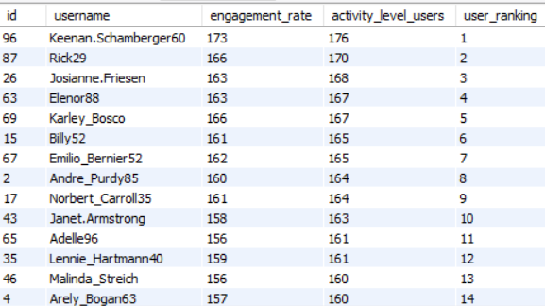

In this query, I calculated and ranked user engagement and activity levels. I started by creating three CTEs to count user interactions: the first CTE calculates the total comments per user, the second counts likes per user, and the third counts total posts per user. I then combined these in a fourth CTE called user_engagement, where I calculated each user's engagement rate (sum of comments and likes) and activity level (sum of posts, comments, and likes). Finally, I ranked users based on their activity level and engagement rate, filtering only those above the average for both metrics. The final result displays the ranking and orders the users by activity level and engagement.

1. For inactive users, what strategies would you recommend to re-engage them and encourage them to start posting or engaging again?

Answer-

with comments_per_users as (

select user_id, count(id) as total_coments_per_user

from comments

group by 1

),

likes_per_users as (

select user_id, count(photo_id) as likes

from likes

group by 1

),

posts_per_user as (

Select user_id, count(image_url) as total_posts

From photos

Group by 1

),

user_engagement as (select id, username, sum(total_coments_per_user + likes) as engagement_rate,

sum(total_posts + total_coments_per_user + likes) as activity_level_users

from users u

left join likes_per_users l

on u.id = l.user_id

left join comments_per_users c on u.id = c.user_id

left join posts_per_user p on u.id=p.user_id

where l.user_id is null

group by 1

)

select username as Inactive_users

from user_engagement

order by 1;

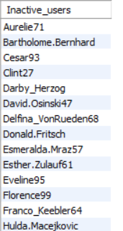

In this query, I retrieved a list of inactive users based on their engagement and activity levels. First, I created three CTEs: the first one counts the total comments per user, the second counts likes per user, and the third counts total posts per user. I then combined these in a fourth CTE called user_engagement, where I calculated each user's engagement rate and activity level. The key part is that I used LEFT JOIN to include users even if they haven't liked, commented, or posted anything, filtering for users where likes_per_users is null. Finally, I selected and displayed the usernames of these inactive users, ordered alphabetically.

1. Which hashtags or content topics have the highest engagement rates? How can this information guide content strategy and ad campaigns?

Answer-

with avg_like_count_cte as (select avg(like_count) as avg_likes from

(Select p.id as photo_id, count(l.created_at) as like_count

from photos p

join likes l

on p.id=l.photo_id

group by p.id) alias)

select tag_name, like_count from (select distinct tag_name, like_count,

row_number() over(partition by tag_name order by like_count desc) as rn

from (select l.photo_id, t.tag_name, count(l.created_at) as like_count

from likes l

join photo_tags pt

on l.photo_id=pt.photo_id

join tags t

on pt.tag_id=t.id

group by l.photo_id, t.tag_name

having count(l.created_at) > (select avg_likes from avg_like_count_cte)

order by like_count desc) alias) alias

where rn=1

order by like_count desc

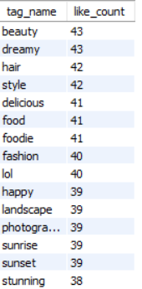

In this query, I identified hashtags or content topics with the highest engagement rates by focusing on likes. First, I created a CTE (avg_like_count_cte) to calculate the average number of likes per post. Then, I retrieved the hashtags that are associated with posts receiving more likes than the average, using joins between the likes, photo_tags, and tags tables. I used row_number() to rank the hashtags by like count and filtered the top-performing hashtags. Finally, I selected and displayed the hashtags with the highest engagement rates, ordered by the number of likes.

This information can guide content strategy and ad campaigns by highlighting the most engaging topics, allowing for targeted promotions and content that resonates with users based on historical data.

1. Are there any patterns or trends in user engagement based on demographics (age, location, gender) or posting times? How can these insights inform targeted marketing campaigns?

Answer-

with time_of_likes as (

SELECT

photo_id,

TIME(created_at) AS likes_time,

COUNT(photo_id) AS num_likes

FROM

likes

GROUP BY 1 , 2

),

time_of_comments as (

SELECT

photo_id,

TIME(created_at) AS comments_time,

COUNT(comment_text) AS num_coments_per_users

FROM

comments

GROUP BY 1 , 2

),

time_based_engagement as (

SELECT

TIME(created_dat) AS post_time,

comments_time,

likes_time,

SUM(num_coments_per_users + num_likes) AS Engagement_rate

FROM

photos p

JOIN

time_of_likes c1 ON p.id = c1.photo_id

JOIN

time_of_comments c2 ON p.id = c2.photo_id

GROUP BY 1 , 2 , 3

)

SELECT

*

FROM

time_based_engagement

ORDER BY 1;

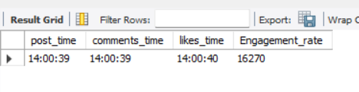

Explaination-

This SQL query analyzes user engagement on photos by examining the timing of likes and comments. It first creates two subqueries: time_of_likes and time_of_comments. In these, it groups likes and comments by photo ID and the exact time (TIME(created_at)) they were created. The time_of_likes subquery counts the likes per photo at specific times, while time_of_comments counts the number of comments per photo during those times.

Next, the query combines these two results into a new table time_based_engagement, where it joins the photos table with the time_of_likes and time_of_comments tables on the photo ID. It then calculates the overall engagement rate (sum of likes and comments) for each photo by the time they were posted, and the time of corresponding likes and comments. The final result is sorted by the post time (post_time), providing a time-based analysis of engagement for photos.

This approach helps understand how engagement (likes and comments) fluctuates based on the time of posting and interaction.

1. Based on follower counts and engagement rates, which users would be ideal candidates for influencer marketing campaigns? How would you approach and collaborate with these influencers?

Answer

with Users_follow_count as (

SELECT

followee_id, COUNT(DISTINCT follower_id) AS Follower_count

FROM

follows

GROUP BY 1

),

like_per_user as (

SELECT

user_id, COUNT(photo_id) AS num_likes

FROM

likes

GROUP BY 1

),

comments_per_user as (

SELECT

user_id, COUNT(comment_text) AS num_coments_per_users

FROM

comments

GROUP BY 1

),

Ranked_Users_for_marketing as (

SELECT

username AS Platform_Username,

Follower_count,

SUM(num_coments_per_users + num_likes) AS Engagement_rate,

DENSE_RANK() OVER(ORDER BY SUM(num_coments_per_users + num_likes) DESC, follower_count DESC) as Rankings

FROM

users u

JOIN

Users_follow_count c1 ON u.id = c1.followee_id

JOIN

like_per_user l ON u.id = l.user_id

JOIN

comments_per_user c2 ON u.id = c2.user_id

GROUP BY 1 , 2

)

SELECT

*

FROM

Ranked_Users_for_marketing;

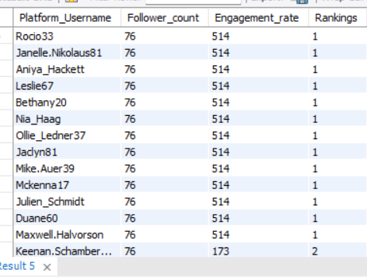

1. Based on user behavior and engagement data, how would you segment the user base for targeted marketing campaigns or personalized recommendations?

Answer-

with like_per_user as (

SELECT

user_id, COUNT(photo_id) AS num_likes

FROM

likes

GROUP BY 1

),

comments_per_user as (

SELECT

user_id, COUNT(comment_text) AS num_coments_per_users

FROM

comments

GROUP BY 1

),

Tags_per_user as (

SELECT

tag_name, user_id

FROM

tags t

JOIN

photo_tags pt ON t.id = pt.tag_id

JOIN

photos p ON p.id = pt.photo_id

),

Ranked_Users_for_marketing as (

SELECT

username AS Platform_Username,

tag_name as Users_Tags,

SUM(num_coments_per_users + num_likes) AS Per_Tag_Engagement_rate,

dense_rank() OVER(PARTITION BY username ORDER BY SUM(num_coments_per_users + num_likes) DESC) AS Users_Per_tag_ranking

FROM

users u

JOIN

like_per_user l ON u.id = l.user_id

JOIN

comments_per_user c2 ON u.id = c2.user_id

join

Tags_per_user t on u.id = t.user_id

GROUP BY 1 , 2

)

SELECT

*

FROM

Ranked_Users_for_marketing

where Users_Per_tag_ranking = 1

ORDER BY 3 desc,1;

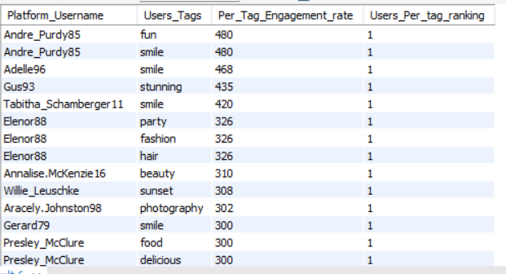

This query identifies and ranks users based on their engagement (likes and comments) across specific tags for marketing purposes. First, it calculates the total number of likes and comments per user in the like_per_user and comments_per_user subqueries. Then, the Tags_per_user subquery associates each user with the tags they’ve used by joining the tags, photo tags, and photos tables. In the Ranked_Users_for_marketing step, it sums the likes and comments for each user and tag to calculate the "Per_Tag_Engagement_rate" and ranks users per tag using DENSE_RANK(). Finally, it filters the result to show only the top-ranked users for each tag, ordering them by engagement rate for marketing insights.

1. If data on ad campaigns (impressions, clicks, conversions) is available, how would you measure their effectiveness and optimize future campaigns?

Answer- To measure and optimize the effectiveness of ad campaigns using data on impressions, clicks, conversions, and user-liked tags, start by defining KPIs such as CTR (click-through rate) and conversion rate. Segment the data by user-liked tags to analyze the performance of each tag. Conduct A/B testing to compare different ad variations targeting various tags and assess their effectiveness. Use the insights from these tests to optimize your targeting by focusing on high-performing tags. Refine your ad creatives to highlight popular tags and test different messages to find what resonates best with your audience. Allocate your budget more effectively by increasing spending on tags that drive higher engagement and conversions, while reducing it for underperforming tags. Continuously monitor the performance metrics and make data-driven adjustments to your campaigns. Regularly summarize insights and key takeaways to inform and improve future ad strategies.

1. How can you use user activity data to identify potential brand ambassadors or advocates who could help promote Instagram's initiatives or events?

Answer-

*select distinct u.id as user_id, t.tag_name*

*from users u*

*join follows f on u.id = f.followee_id*

*join photos p on u.id=user_id*

*join photo_tags pt on p.id=pt.photo_id*

*join tags t on t.id=pt.tag_id*

*where u.id in*

*-- the following code gives users the most number of followers*

*(select user_id from (select user_id, follower_count,*

*dense_rank() over(order by follower_count desc) as rnk*

*from (select u.id as user_id, count(f.follower_id) as follower_count*

*from users u*

*join follows f on u.id = f.followee_id*

*group by u.id) alias1) alias2*

*where rnk=1)*

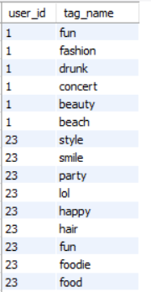

The above table represents user ids with most number of followers and the tags they have used in the posts they shared on the social media platform. These users can be potential influencers for the topics/tags they used in their posts.

1. How would you approach this problem, if the objective and subjective questions weren't given?

**Answer**- Enough data is not available to answer the questions more meaningfully. For user behaviour, we only have the data of tags which users have liked. Owing to lack of data, few questions could not be answered.

However, if the above questions were not available I would have taken a similar approach. But it is safe to say, these questions have helped me to see the data in a more meaningful way.

1. Assuming there's a "User_Interactions" table tracking user engagements, how can you update the "Engagement_Type" column to change all instances of "Like" to "Heart" to align with Instagram's terminology?

Answer

To update the "Engagement_Type" column in the "User_Interactions" table, changing all instances of "Like" to "Heart", we can use the following SQL code:

*update User_Interactions*

*set Engagement_Type = 'Heart'*

*where Engagement_Type = 'Like';*

This code will find all rows in the "User_Interactions" table where the "Engagement_Type" is "Like" and update them to "Heart".